PAAREES Perfumes

DUNHILL Men

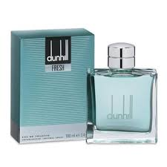

**DUNHILL Only the for Men**

Key Features

* Head notes of **DUNHILL** Plus Plus Masculine : bergamot, orange, palm leaf, heliotrope
* Base notes of Masculine by **DUNHILL**: vetiver, musk, sandalwood, patchouli, oakmoss, nutmeg, cloves, cinnamon, anise, tonka bean
* Heart notes of Plus Plus Masculine by **DUNHILL**: jasmine, birch, sage, cardamom, coriander, lily, violet, green tones
* **DUNHILL** PLUS PLUS Masculine is a vibrant fragrance full of life.